Part-3 Chapter-13

Aplia Homework: Limiting Market Power: Regulation and Antitrust

**1. Antitrust laws**

Monopoly power runs counter to the public interest because it leads to high prices, resource misallocation, and inefficiency. Antitrust policy is one of the government's instruments for curbing monopoly power and protecting competition.

Suppose that two U.S. investment banks negotiate a merger agreement because a financial crisis threatens to bankrupt both firms.

This merger has to be approved by the Department of Justice (DOJ) and the Federal Trade Commission (FTC) under which of the following laws?

The Hart–Scott–Rodino Act of 1976

The Clayton Act of 1914

The Robinson–Patman Act of 1936

The Sherman Antitrust Act of 1890

**2. Interpreting concentration ratios**

The following table shows the four-firm concentration ratios of various industries.

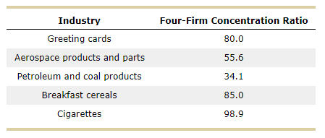

Based on the data presented in the table, which of the following industries is the closest to perfect competition?

Aerospace products and parts

Greeting cards

Cigarettes

Petroleum and coal products

Breakfast cereals

**3. The Herfindahl-Hirschman index**

Suppose that three firms make up the entire tire manufacturing industry. One has a 60% market share, and the other two have a 20% market share each.

The Herfindahl-Hirschman index of this industry is _______.

Tread tough, one of the firms with a 20% market share in the tire manufacturing industry, leaves the market.

This would cause the Herfindahl-Hirschman index for the industry to ______.

Why the largest possible value of the Herfindahl-Hirschman index is 10,000?

An index of 10,000 corresponds to 100 firms with a 1% market share each.

An index of 10,000 corresponds to a monopoly firm with 100% market share.

An industry with an index higher than 10,000 is automatically regulated by the Justice Department.

**4. Questionable business practices according to antitrust agencies**

Complete the following table by indicating whether each of the scenarios describes the concept of tying, bottleneck, or predatory pricing.

| **Scenario** | **Tying** | **Bottleneck** | **Predatory Pricing** |
| --- | --- | --- | --- |
| Union Southwest is a railroad company that built and owns the only bridge to and from Coronado island to the mainland United States. Since there are no airports or boating docks in Coronado, any firms that want to ship goods from the mainland United States must use Union Southwest's trains and bridge. This makes it difficult for other shipping and freight companies in the area to compete with Union Southwest. | _____ | _____ | _____ |  |
| Sackville sells a wide variety of snacks to retail grocery stores. Sackville recently released two new snacks: a popular trail mix and a much less popular granola bar. Sackville requires grocery stores to buy 15 cases of the granola bar for every 120 cases of the trail mix ordered. | _____ | _____ | _____ |  |
| Heat-Em-Up is the only firm producing grills. It costs $410 to produce a grill, and Heat-Em-Up sells each grill for $950. After Well Done, a new firm with the same costs as Heat-Em-Up, enters the market for grills, Heat-Em-Up starts selling its grills for a price of $330. | _____ | _____ | _____ |  |

True or False: By bundling the two snacks together, Snackyville can force grocery stores to pay more than they would be willing to pay when purchasing the snacks separately.

True

False

**5. When fewer firms are better**

Burley Spuds Inc. turns potatoes into ready-to-cook French fries. Burley's production facility initially operated for one daytime shift. The firm’s management then decided to add an evening shift in order to use the facility to produce ready-to-cook tater tots. Using the facility in the evening allows Burley to produce tater tots at a lower average cost than its competitors can. This is an example of:

Economies of scope

Constant returns to scale

Increasing returns to scale

Decreasing returns to scale

**6. Issues that face regulators**

Which of the following are reasons why the regulatory goal of making big firms smaller is not always desirable? Check all that apply.

It may prevent consumers from benefiting from the lower prices associated with economies of scale.

It may adversely affect income distribution.

It may constrain large-scale research and development (R&D).

**7. Regulating a natural monopoly**

Consider the local cable company, a natural monopoly. The following graph shows the monthly demand curve for cable services, the company's marginal revenue (MR), marginal cost (MC), and average cost (AC) curves.

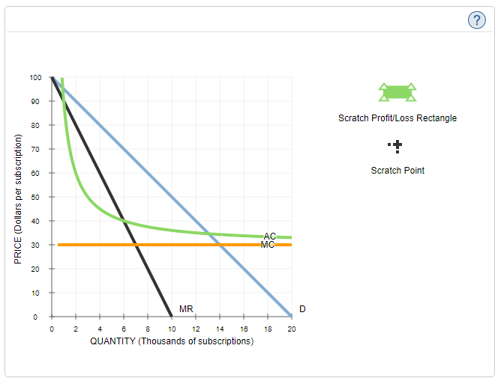

Suppose that the government has decided not to regulate this industry, and the firm is free to maximize profits without constraints.

Complete the first row of the following table. You may use the green scratch rectangle (triangle symbols) as well as the black scratch point (plus symbol) on the graph to determine the information necessary to fill in the table. You will not be graded on where you place the rectangle and point on the graph.

**Hint**: After placing the point on the graph, you can see the coordinates by clicking and holding the point. After placing the rectangle on the graph you can see the coordinates of the corners by clicking them. You can also see the area of the rectangle by clicking on the interior after placing it on the graph.

| **Pricing Mechanism** | **Short Run** | | | **Long-Run Decision** |
| --- | --- | --- | --- | --- |
| **Quantity** | **Price** | **Profit** |
| ***(Subscriptions)*** | ***(Dollars per subscription)*** |
| **Profit Maximization** | **_______** | **_______** | **_______** | **_______** |
| **Marginal-Cost Pricing** | **_______** | **_______** | **_______** | **_______** |
| **Average-Cost Pricing** | **_______** | **_______** | _______ | **_______** |

Suppose that the government forces the monopolist to set the price equal to marginal cost.

Complete the second row of the previous table.

Suppose that the government forces the monopolist to set the price equal to average cost.

Complete the third row of the previous table.

Under profit regulation or average-cost pricing, the government will raise the price of output whenever a firm's costs increase, and lower the price whenever a firm's costs decrease. Over time, under the average-cost pricing policy, what will the local cable company most likely do?

Work to decrease its costs

Allow its costs to increase

**8. The effects of deregulation**

Which of the following statements best summarizes the effects of deregulation of the airline industry in the United States?

Deregulation has lowered prices, increased wages, and decreased competition among carriers.

Deregulation has lowered prices, reduced passenger safety, and decreased competition among carriers.

Deregulation has lowered prices, reduced passenger comfort, and hurt the airline pilots' union.